IIME ASSIGNMENT III

Varun Mahendra Khadayate, Btech (SY)

NMIMS

Author Note

ROLL NO. A016

SAPID: 70362019028

# Business Idea Summary

## What is the product/service?

The product is a database server warehouse. The services provided are collection of data, storing it, processing it and giving a desired output to the end user.

### Mind Map

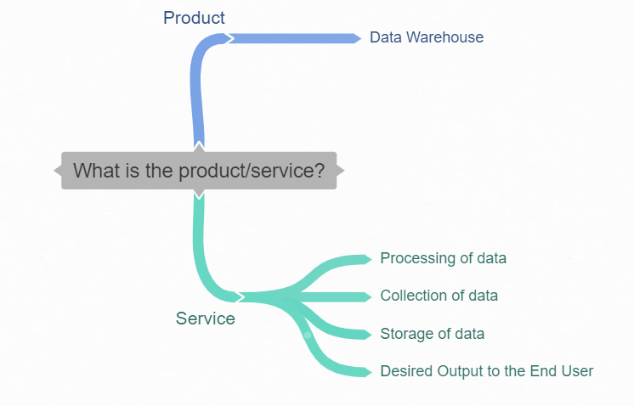

## What does it do?

This product mainly gives us an ease at the work overload of a regular merchant/worker in maintaining the record and storing it.

### Mind Map

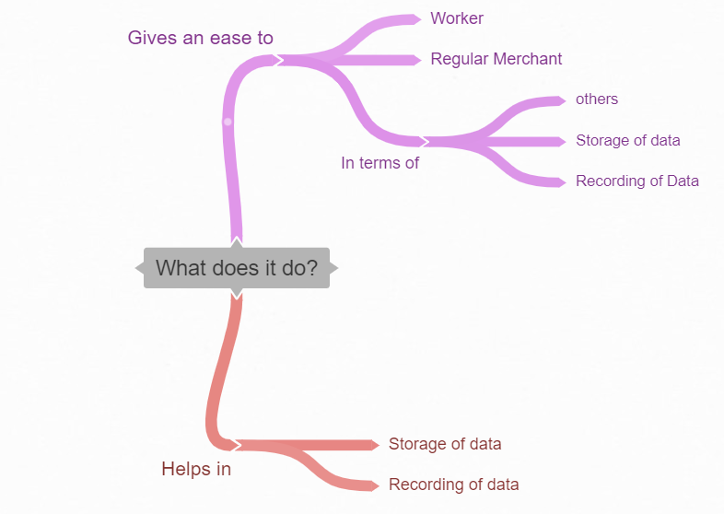

## Who are the customers? How many?

The customers are big port and airport management services/firms like CSIA JNPT and others. The number depends on the interested party in this product but as of me the number is up to 2000 Customers

### Mind Map

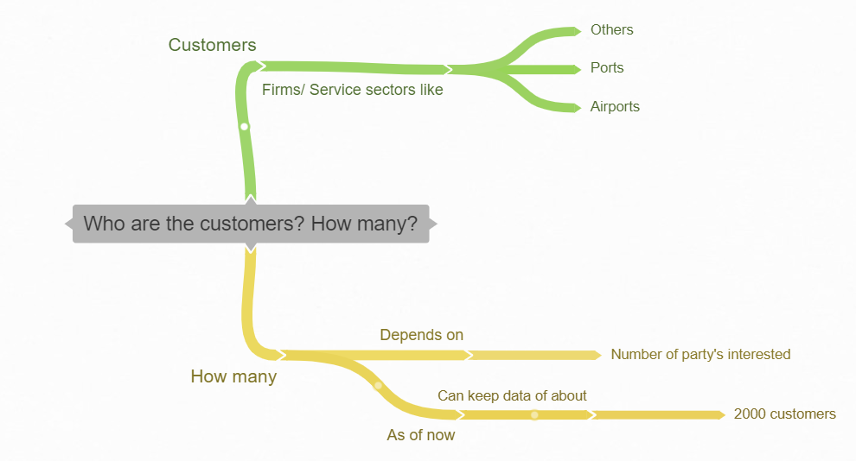

## How do you believe you will get paid?

Since by storing the data and making it in located in a prime location may help in earning revenue in both as a tourist spot and also as a storage warehouse.

### Mind Map

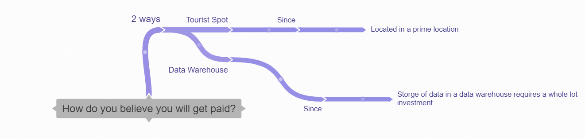

## Why is this better than the currently available product/services?

Since many industries are evolving with the current tech its now time for the evolvement of the major revenue collector of India the PORTS and AIRPORTS. Its one of the top sectors for employment and since if we take an example of ports the JNPT Port where lacs of ships are birthing and sailing and for managing input and output of import of goods/container management requires a huge amount of data need to be stored, I am here to reduce the overload and making it an easy to work with by proving it with a datacenter. And since there is a less investment for employment and more on infrastructure it will boost the overall GDP of the country as well.

### Mind Map

